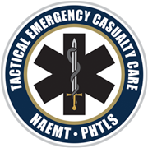
TECC
Tactical Emergency Casualty Care

Topics covered include:  - Three phases of tactical care and integrates parallel EMS nomenclature  - Hemorrhage control including immediate action drills for tourniquet application throughout the course  - Complete coverage of the MARCH assessment  - Surgical airway control and needle decompression  - Strategies for treating wounded responders in threatening environments;  - Caring for pediatric patients  - Techniques for dragging and carrying victims to safety  - A final, mass-casualty/active shooter event simulation. | Who: ALS and BLS  When: December 3rd & 4th , 2022  8 am – 5 pm  Where: Charles County Mobile  Intensive Care Unit  10700 Billingsley Road  White Plains, MD 20695
Space is limited. Seats will be on a first come, first serve basis.
Email kellnert@charlescountymd.gov to reserve your seat by November 3rd .

Worth 16 hours of continuing education credits
Response to and care for a patient in a civilian tactical environment

